tlog2chart_P3 — User Manual

Version: v1.3.5
Scope: Visualize tlog RF power, caps, and each voltage

Contents
tlog2chart_P3 — User Manual 1
1. Overview 2
2. Main Tabs 3
2.1 Graph Tab 3
2.2 Parameters Tab 5
2.3 Tlog Array Tab 6
2.4 Smith Chart Tab 6
2.5 Analysis Input Tab (Task G) ✅ 6
3. Analysis Workflow 8
4. Step 3 — Custom Time‑Range Analysis (Task G) 10
4.1 Step 3 Figure 10
4.2 Step 3 Metrics Table 10
5. Word Report Export 11
6. Units & Timebase Summary (Important) 13
7. Common Mistakes & Tips 14
8. Version Notes (v1.3.5) 15

1. Overview
tlog2chart_P3 is a GUI tool for analyzing RF generator tlog data.
It allows users to:

Visualize RF power, caps, and bias signals
Inspect raw tlog data
Analyze RF behavior in a user‑defined time window
Generate a Word report that reflects exactly what the user selected on the graph

Recommended workflow:
Load tlog → study Graph → decide time window → Analysis Input → Run Analysis → Export to Word Report

2. Main Tabs
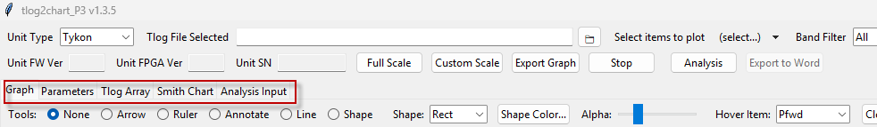

2.1 Graph Tab
The Graph tab is the primary analysis workspace.
Key features
Multi‑panel plot (Power / Caps / Bias)
X‑axis uses time in seconds t(s)
Interactive tools:
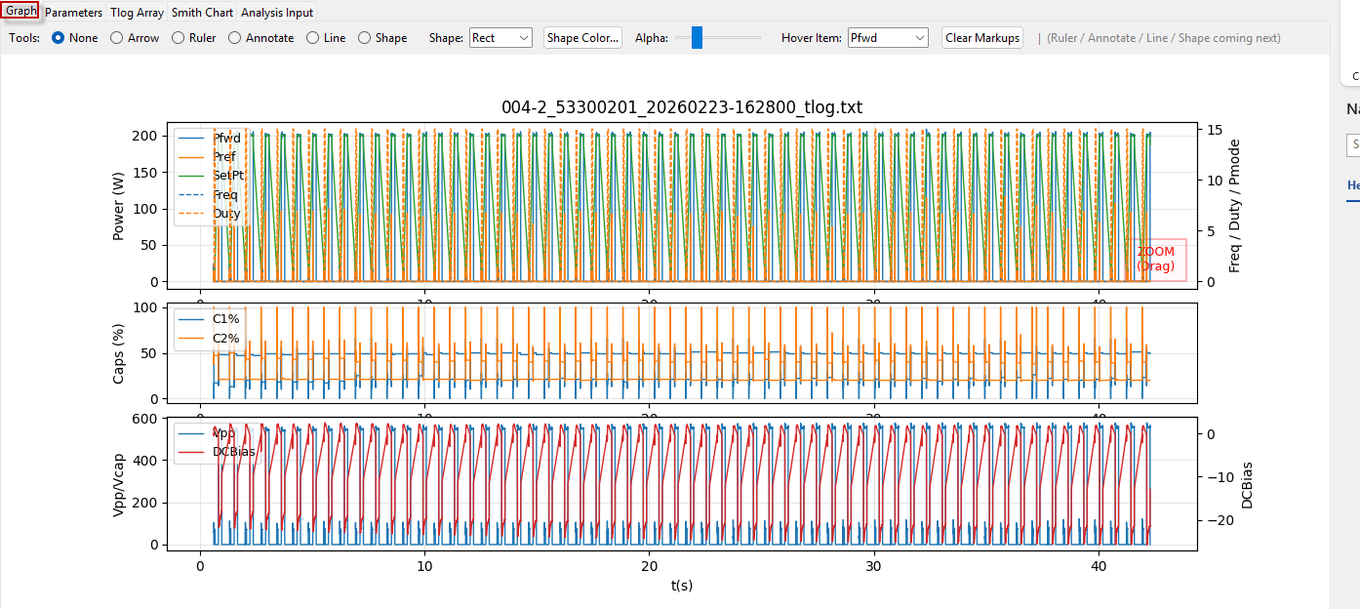
Zoom & pan
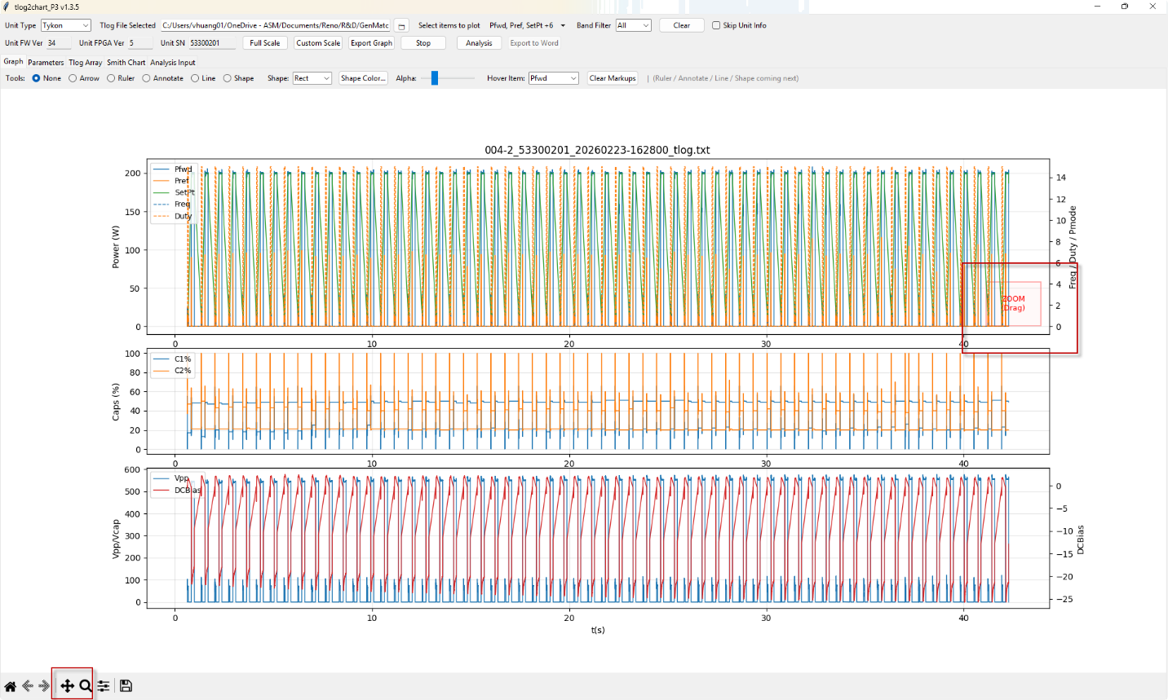
Ruler (time & value measurement)
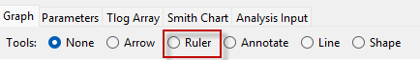
Hover tooltip showing:
row()
t(s)
signal value
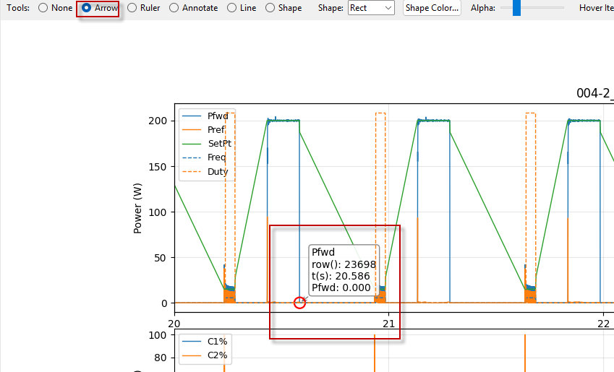

Important

The graph timebase is seconds, not milliseconds.
All analysis time windows are interpreted against this axis.

2.2 Parameters Tab
Displays parsed tlog parameters in a structured table.
Section / Parameter / Value / Description
Read‑only reference information
Useful for understanding generator configuration

2.3 Tlog Array Tab
Raw tlog data browser.
Features

Paginated view (2500 rows per page)
Horizontal & vertical scrollbars
Go‑to‑row function
Right‑click row highlighting

Use cases

Inspect exact numeric values
Cross‑check timestamps (t(s), time(ms), etc.)
Debug abnormal behavior seen in Graph

2.4 Smith Chart Tab
Displays load impedance trajectory.

Smith chart with Z₀ = 50 Ω
Based on EVC Zload data
Visual separation between chart and info panel

2.5 Analysis Input Tab (Task G) ✅
This is the new tab introduced in this version.
Purpose
Define a custom time window for Step 3 analysis.
Inputs

Start (s)
End (s)

Both values are in seconds, consistent with the Graph x‑axis.
Buttons

Preview
Shows the parsed time range and validates it.
Clear
Resets the fields.

Validation behavior

If fields are blank → default analysis is used
If non‑numeric → warning
If Start > End → warning
If outside graph time span → warning and analysis is blocked

✅ This prevents accidental inputs like 20000–23000 that are out of range.

3. Analysis Workflow
Step 1 — Load Tlog

Open the application
Load a valid tlog file
Graph and Tlog Array populate automatically

Step 2 — Inspect Graph

Use zoom and ruler tools
Identify the region of interest on t(s) axis
Example: 20.0 – 23.0 s

Step 3 — Define Analysis Window (Optional)

Go to Analysis Input
Enter:

Start (s): 20
End (s): 23

Click Preview to confirm

If left blank, the tool falls back to default behavior.

Step 4 — Run Analysis

Click Analysis
The tool generates analysis artifacts:

Step 1: Full‑scale overview
Step 2: Zoom near last power event
Step 3: Custom time‑range analysis (Task G)

4. Step 3 — Custom Time‑Range Analysis (Task G)

4.1 Step 3 Figure

Uses time slicing, not cycle index slicing
Plots exactly the data within the user‑defined window
Timebase matches the Graph (seconds)

Title
Step 3 — Customize time range analysis (20.0–23.0 s)

This guarantees:

What you see on Graph = what you get in the report

4.2 Step 3 Metrics Table

Analyzes all RF cycles overlapping the selected time window
Not limited to “first 6 cycles” anymore
Cycle numbering restarts at 1 within the selected window

This provides meaningful, context‑specific metrics.

5. Word Report Export
How to export

After Analysis completes, click Export Word Report

Report contents
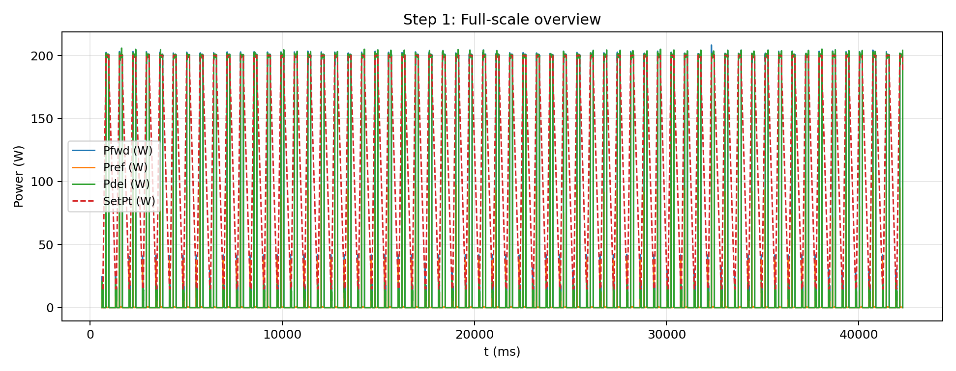
Figure 1: Full‑scale overview
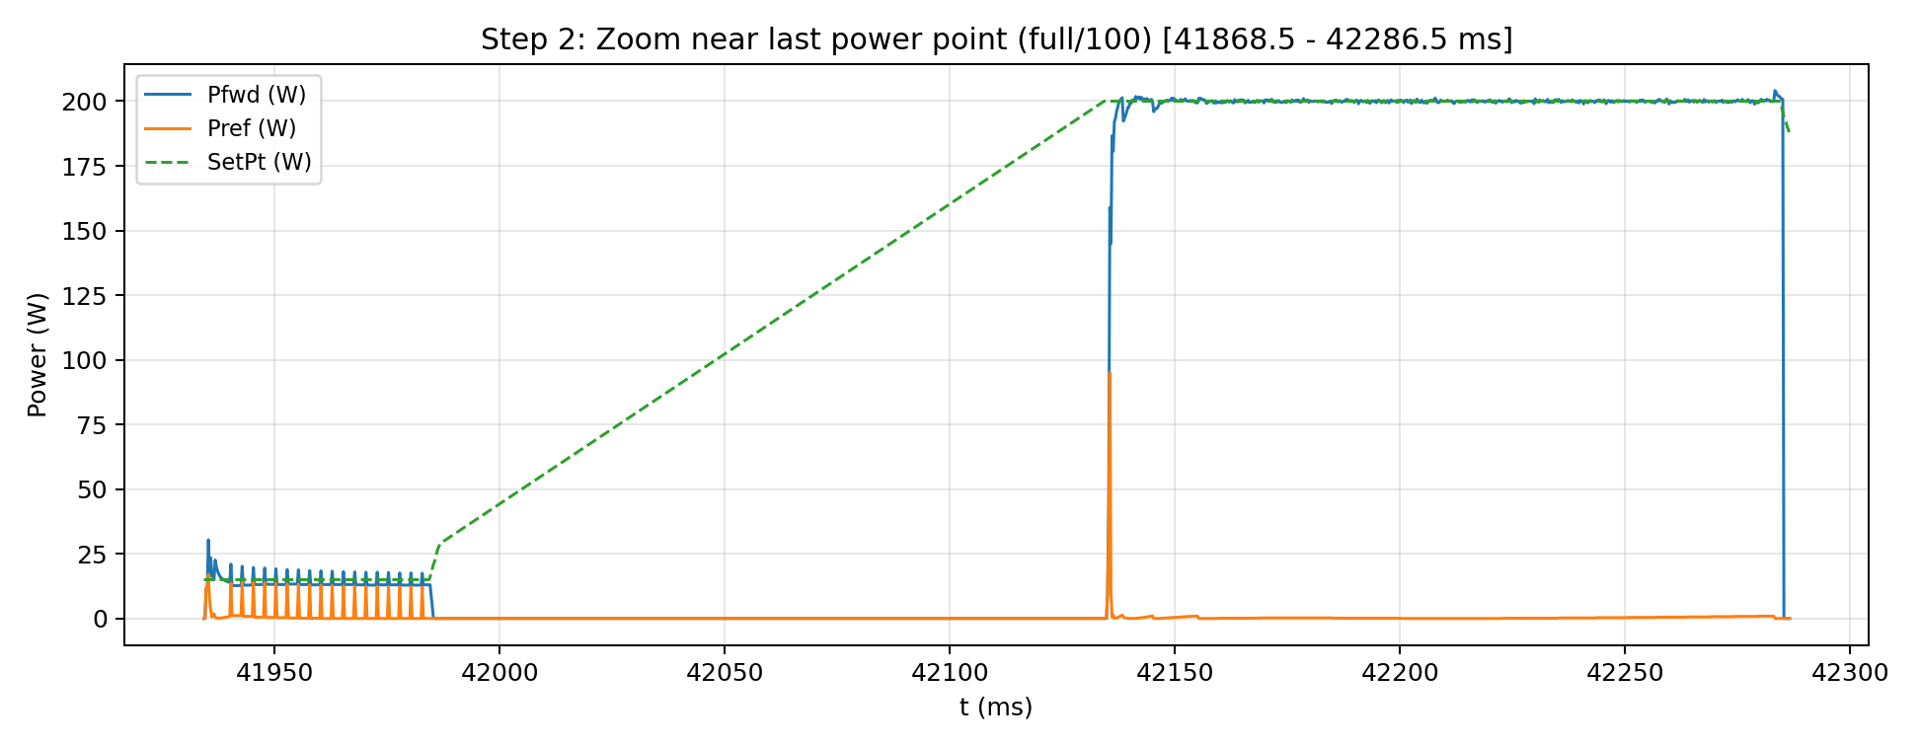
Figure 2: Zoomed power event
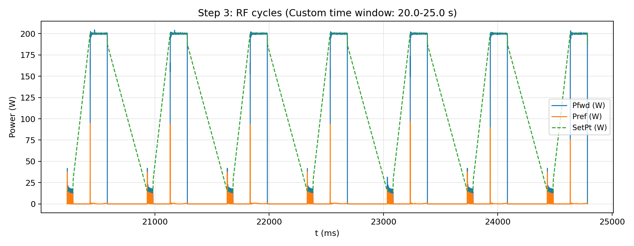
Figure 3: Custom time‑range analysis
Step 3 table reflects only cycles in the selected window

Guaranteed behavior

Figure 3 is embedded if data exists
No silent failures
Titles and captions match the analysis mode

6. Units & Timebase Summary (Important)

Location | Unit | Source
Graph x-axis | seconds t(s) | df["t(s)"]
Analysis Input | seconds | User input
Step 3 slicing | seconds | Time window
Report Figure 3 | seconds | Consistent

Rule: Always read the Graph first, then enter the same values for analysis input in seconds.

7. Common Mistakes & Tips
❌ Entering milliseconds (e.g. 20000–23000)

Will be rejected as out of range
Correct input would be 20–23

✅ Best practice

Use ruler tool on Graph to read exact start/end in seconds
Copy those numbers into Analysis Input

8. Version Notes (v1.3.5)
[1.0.0] – Initial
### Added
- Basic tlog parsing
- Graph visualization
- Smith chart visualization
## \[1.1.0] – 2025-02-20
### Added
- Phase 3 analysis framework
- Step 1–5 analysis flow
- Word report export (PNG figures + tables)
### Changed
- Added RF-cycle-based analysis concept
## \[1.2.0] – 2026-03-03
### Changed
- Refactored from a single-file script into a multi-module project structure
- Separated GUI, data parser, plotting, and analysis logic
- Improved maintainability and extensibility without changing behavior
### Fixed
- RF ON/OFF detection unified to use RF:UC (\* / -)
- Step 3 RF-cycle metrics consistency
### Verified
- Phase 3 analysis Step 1–5
- Single tlog workflow
- Word report export
## [1.3.1] – 2026-03-05
### Changed
- Ruler tool upgraded to JMP-style drag workflow (press→drag preview→release finalize)
- Support multiple ruler lines (temporary markups)
### Fixed
- Hover interactions stabilized across Graph and Smith chart
## [1.3.2] – 2026-03-xx
### Added
- Annotate tool (click → input text → place label; multiple; Clear Markups supported)
### Changed
- Tool routing: zoom zone always wins across all tool modes
### Fixed
- Prevent Ruler from falling back to legacy two-click handler (legacy kept but unused)
## [1.3.3] – 2026-03-xx
### Added
- Line tool (press → drag preview → release finalize)
- Multiple lines supported (temporary markups)
### Changed
- Clear Markups removes rulers + annotations + lines
- Zoom zone always wins across all tool modes
### Notes
- Custom color will be implemented for Shape tools (Rect/Circle) in next task
## [1.3.4] – 2026-03-xx
### Added
- Shape tool (Rect/Circle): press → drag preview → release finalize
- Multiple shapes supported
- Custom shape color + translucent fill (alpha)
### Fixed
- Shape drag state stable (no ghost preview, no disappear on second click)
## [1.3.5] – 2026-03-xx
### Added
- New “Analysis Input” tab
- Step 3 custom time-range analysis (user enters start/end time; report focuses on that window)
### Changed
- Step 3 report title and narrative updated to reflect custom time-range analysis
- Step 3 metrics table now analyzes cycles/segments within the user-selected time window (not limited to first 6)
### Fixed
- Prevent out-of-range Step 3 inputs via GUI validation (warn if outside data range)
- Align Step 3 analysis timebase with Graph timebase to avoid mismatch between Graph and report

